Tutorial 2 Answer

1. Theory

Answers

Ex 1.

| 1. composite attribute 2. associative entity 3. unary relationship 4. weak entity 5. attribute 6. entity 7. relationship type 8. cardinality constraint 9. degree 10. identifier 11. entity type 12. ternary | i. can be broken into component parts  b. relates instances of a single entity type  c. specifies maximum and minimum number of instances  d. relationship modeled as an entity type  e. association between entity types  f. collection of similar entities  g. number of participating entity types in relationship  h. property of an entity  j. depends on the existence of another entity type  a. uniquely identifies entity instances  k. relationship of degree 3  l. person, place, object, concept, event |
| --- | --- |

1.i 2d. 3.b. 4j. 5h. 6l. 7e. 8c 9g. 10a. 11.f. 12.k

Ex 2. Contrast the following terms:

1. *Stored attribute; derived attribute*  A stored attribute is one whose values are stored in the database, while a derived attribute is one whose values can be calculated or derived from related stored attributes.
2. *Simple attribute; composite attribute*  A simple attribute is one that cannot be broken down into smaller components, while a composite attribute can be broken down into component parts.
3. *Entity type; relationship type*  An entity type is a collection of entities that share common properties or characteristics, while a relationship type is a meaningful association between (or among) entity types.
4. *Strong entity type; weak entity type*  A strong entity type is an entity that exists independently of other entity types, while a weak entity type depends on some other entity type.
5. *Degree; cardinality* The degree (of a relationship) is the number of entity types that participate in that relationship, while cardinality is a constraint on the number of instances of one entity that can (or must) be associated with each instance of another entity.
6. *Required attribute; optional attribute*  A required attribute must have a value for each entity instance, whereas an optional attribute may not have a value for every entity instance.
7. *Composite attribute; multivalued attribute* A composite attribute has component parts that give meaning, whereas a multivalued attribute may take on or more values for an entity instance.

*Ex 3*

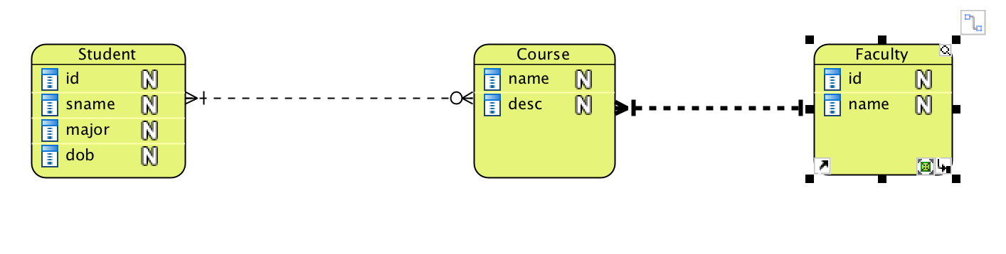

*Ex 4*

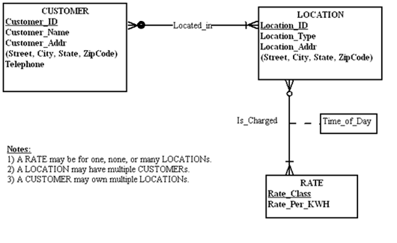

Ex 5.

